# Team 302

# Team Goals

1. Create a hands-free device that is simple to use and easy to maintain.
2. Employ the use of sustainable designs and materials to deliver an environmentally cohesive product.
3. Make something we can at least build off of in the future for a cohesive project
4. Create a project that we can add to our portfolio for future employment
5. Foster a favorable work environment to foster building connections

# Charter

The project's goal is to develop a hands-free gadget that is straightforward to use and maintain, uses ecologically friendly designs and materials to produce a product, and may be expanded upon in the future for an end product. Along with creating a project we can add to our resumes for potential employers, the project team hopes to promote a positive work environment that encourages collaboration.

# Mission Statement

We believe that all people deserve access to reliable, easy-to-use, and comprehensible weather information. The goal of our product is to make that a reality for people who don’t necessarily occupy one place. We use the most up-to-date technology to give our users the best experience possible. We use the latest sensors, actuators, and are always innovating to make our product better. We are passionate about making a positive impact on the world around us. We believe our product can keep people safe and make decisions about their lives while they are on the go.

# Communication Channels

| Name | 1st Choice Comm. | 2nd Choice Comm. | 3rd Choice Comm. |
| --- | --- | --- | --- |
| [Marla Hawthorne](mailto:mmhawth1@asu.edu) | Discord | Canvas | Email |
| [Elton Salt](mailto:esalt@asu.edu) | Discord | Email | Cellphone |
| [Kalin Comins](mailto:kmcomins@asu.edu) | Discord | Email | Canvas |
| [Enyinnaya Onyenso](mailto:eonyenso@asu.edu) | Discord | Email | Canvas |

Table 1: Preferred Communication Channels

# Communication Procedures

All communication will first take place on Discord. Discord will be our primary source of information, where information from instruction or other sources will be placed by whomever receives it first. This will allow everyone in your group to stay connected to the most up-to-date information available. All members will use Discord to communicate and discuss any instructor correspondence in order to progress with our project.

# Meeting Schedule

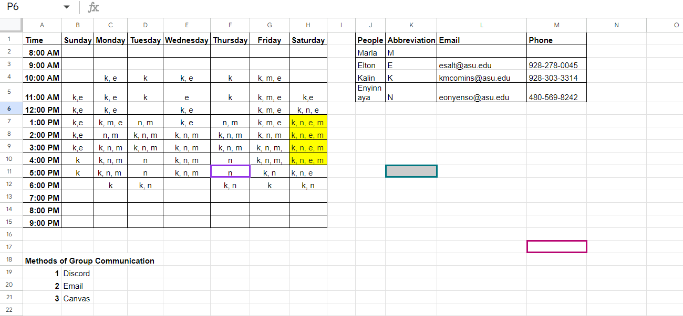

Figure 1: Individual Meeting Schedules ([LINK](https://docs.google.com/spreadsheets/u/0/d/1bK6ih4qioO3wMOxa_bG0y6sWVmxXtRqhoMafalZDSg8/edit))

## Meeting Coordination

1. We will use a discord reminder tool to keep track of meetings.
2. Our team will adjust or add meeting dates as needed via discord meetings and notifications.
3. The preferred meeting format is virtual, but meetings can also take place in person.
4. Our team doesn't feel there are any other procedures necessary at this time, if need be, we can revise this document to add any additional procedures we agree are necessary.

# 

# 

# 

# Roles and Responsibilities

| Role | Duties | Assignment |
| --- | --- | --- |
| Secretary | Coordinates meetings as necessary | Marla Hawthorne |
| Lead Planner | Makes notes on next steps | Elton Salt |
| Assignment Leader | Keeps time of due dates  Starts documents | Kalin Comins |
| Project Manager | Manages changes in the evolving project | Enyinnaya Onyenso |

Table 2: Role Assignments and Duties

* Project roles can change after each checkpoint.
* Each role is decided by volunteering, and if needed, the group will assign.
* By directly or indirectly aiding those who need it we can help one another meet their responsibilities.
* We will see who needs the most help and adjust the roles so those who may be doing less can help those who may be doing more.
* Team activities and milestones will be tracked using the assignments and checkpoints as larger beacons of progress, while internal milestones and goals will be checked through our communication routes.
* We will assign technical responsibilities by who has the most experience, if experience is equal then paired learning can be incorporated in our assignment.

# Team Coordination & Accountability

* Each assignment will be subject to a review process after completion. If someone objects to the submission of an assignment, the objection is reviewed and/or the assignment is amended/submitted depending on how the review goes. Everyone will have the opportunity to comment on the assignment. If they would like, they may waive their chance to comment at their own discretion.
* The skill or knowledge confirmation will be verbal. In the event of an absence, we will rearrange the duties in an appropriate manner to ensure everyone carries a reasonable workload.
* Feedback will be discussed in a virtual or face-to-face meeting. After such a meeting, feedback will be divided and processed by each member on the team based on their role in providing the feedback. If no role was provided, then the member or members not involved will help those who were.
* To address missed contributions/assignments/actions, a three strikes rule will be implemented. This means that everyone gets three chances(strikes) to make a mistake, after the final chance(strike) a major group meeting will take place with the instructor and possibly result in the offending member receiving a pink slip(out).
* Addressing missed assignments/contributions/actions will take place either in person or virtual in our discord.
* We will hold each other accountable using the three strike rule I mentioned above.
* If an underperforming team member is not putting in the same amount of effort or quality of work as the other members, this will be immediately flagged by the feedback and score we get from the instructor.
* We will help the underperforming member by directly getting involved and bolstering their understanding, performance, and output.
* The consequences of an underperforming member will fall under the three strikes rule laid out above.

# 

# Conflict Recognition & Resolution

All conflicts will be solved in the discord. No deleting of messages will be tolerated. Any major conflicts will be brought to a person with more experience for a second opinion. Any minor issues will be settled with a dice roll.

Major conflicts include:

* Component Selection
* Major individual time allots
* Major Project Decisions
* Project requirements

Minor conflicts include:

* Role/ work assignments
* Total effort output
* Quality of work
* Meeting times

# Signatures

X[Elton Salt](mailto:esalt@asu.edu)

X[Marla Hawthorne](mailto:mmhawth1@asu.edu)

X[Enyinnaya Onyenso](mailto:eonyenso@asu.edu)

X[Kalin Comins](mailto:kmcomins@asu.edu)